ENGL388V-0301 Portfolio
Tamara Garner
ENGL393 Undergraduate Teaching Assistant
Fall 2016

Table of Contents

- Lesson Plans
1.1 Lesson Plan #1: Writing Professional Emails…………………….....3
  - Lesson Plan #2: The Five Canons of Rhetoric……………………....6-8
- Discussion Posts
2.1 Discussion Post Week 4: Theories of How People Learn…………...9-10
  - Discussion Post Week 10: The Inclusive Classroom……………….11-12
  - Discussion Post Week 11: Writing in the Real World…………........13-15
- Learning Logs
  - Learning Log #1……………………………………………………...16
  - Learning Log #2……………………………………………………...17
  - Learning Log #3……………………………………………………...18-19
- Group Presentation Materials
4.1 Discussion Post/Prompt……………………………………….……...20
4.2 Group Reflection/Additional Reflection………….………….……....21-22
- Reflective Essay………………………………………………….……....23-24
- Appendices
Appendix A: Approaches to Style and Error PowerPoint………………....25-30
Appendix B: “Writing Effective Emails” survey results………………….31-32

Instructor: Professor Moses
Course Title: ENGL393: Technical Writing
UTA: Tamara Garner

Lesson Plan #1: Writing Professional Emails
Fall 2016

Overview: This course lesson will take place online. Students will learn how to communicate effectively by email, taking into account the purpose and audience of their message, and the tone they want to convey.
Objective: Students will:
- Construct professional emails, taking into account the purpose and audience of their email, and the message they want to convey
- Articulate and employ general email etiquette
- Demonstrate that they understand the difference between effective and ineffective emails
Instructional Materials Needed:
- Computer
- Internet access
- YouTube Video “Writing Effective Emails” (2 min 45 sec)
- Readings: SlideShare: Writing Effective Emails ,“Writing Professional Emails”, SlideShare: Email Etiquette Presentation (1 hour)
- Writing Professional Emails Feedback Survey (5 min)
How This Is Related: In the ENGL393: Policies and Procedures section, technical communication is very important in this course. Students will be in the process of completing their Final Project Primary Research Rationale, which includes composing two sets of primary research questions in which students will eventually send to an individual of high authority. It is important for students to know how to write for specific audiences and how to compose a professional email to individuals in professional settings such as employers, teachers, teaching assistants, etc. This course lesson will reiterate the importance of effective technical communication through two discussion board exercises, a quiz, and a survey to assess their knowledge.

Overall Time Estimate: Approximately 2 hours and 20 min

Resource materials and Video: First, students will review the resource materials and video pertaining to email etiquette.

Quiz: Second, Students will take an email etiquette quiz to test their understanding of core e-mail etiquette principles that will help them to become a courteous communicator. Email Etiquette link- http://www.netmanners.com/email-etiquette-quiz/ (10 min)

Discussion Board Post #1: Third, in 100-300 words, students will answer the following questions based on their results from the email etiquette quiz.

Questions to consider: (30 min)
- Based on your own knowledge, what did you know about sending effective emails before reading the information provided and taking the quiz? What would you still like to know?
- How did some of the questions in the quiz relate to a real-life situation you had when trying to send an email? For example, how do you respond to insulting emails?
Discussion Board Post #2 (20 min): Students will compose one email in which they will try to arrange a meeting with their gatekeeper, primary, secondary, and tertiary audiences. Students will comment on at least one student’s post on what they did well and what they could improve on in their composed email.
How Students will be assessed: Students will take the email etiquette quiz in order to test their current knowledge. The discussion board post serves a reflection for students to discuss their results from the email etiquette quiz and provide their own person experiences with emailing. The class activity is a way for students to test their knowledge and practice. Lastly, students will complete a quick survey to provide their feedback on the lesson on writing professional emails.

Reflection: In this lesson plan, I wanted to incorporate the strategies from Bloom’s Taxonomy in order to organize objectives that help to clarify objectives for myself and students. It’s important for students to have set learning goals so that they may have a purpose in their work along with understanding. I would also like to focus on Barr and Tagg’s strategy in “From Teaching to Learning: A New Paradigm for Undergraduate Education.” In using Barr and Tagg’s strategy, I can produce learning with every student by providing them with a variety of resources to improve their learning such as articles, videos, discussion questions, practicing writing emails, and the email etiquette quiz. I think that this lesson plan was very successful, I tweaked a few things based on the feedback I received from Professor Moses and Lyra. I used the survey that I had my students complete at the end of the lesson to help me gain insight on how effective this lesson plan was for them and receive constructive criticism on things I could improve on. Based on the results shown in (See Appendix A for results from 25 students), most of them felt like the lesson was moderately effective/helpful to them, but they came close to very effective/helpful as well. Since this was my first time teaching a lesson plan, I think I did well for my first try.

Tamara Garner
October 15, 2016
ENGL388V-0301

Lesson Plan #2: Aristotle’s Five Canons of Rhetoric
Fall 2016

Overview: This course lesson will take place online. Students will learn how to incorporate the five canons of rhetoric invention, arrangement, style, memory, and delivery in order to formulate reports, proposals, etc., considering the purpose and audience of their message, and how they could deliver their document through public speaking.

Objective: Students will be able to:
- Demonstrate an understanding and awareness of the five canons: invention, arrangement, style, memory, and delivery
- Analyze the five canons of rhetoric
- Apply their knowledge of the five canons of rhetoric to the rhetoric appeals
- Test their knowledge by completing an assessment quiz on the five canons of rhetoric
Materials Needed:
- Lesson Plan sheet
- Internet access (e.g. Computer, Laptop, Tablet, etc.)
- PowerPoint Lecture- “The Five Canons of Rhetoric”
- Readings: http://walton.uark.edu/business-communication-center/Resources/downloads/The_Five_Canons_of_Rhetoric.pdf
https://www.memoriapress.com/articles/5-canons-of-rhetoric/
http://catalogue.pearsoned.co.uk/assets/hip/gb/hip_gb_pearsonhighered/samplechapter/0205943586.pdf
- Quiz (provided on a separate sheet)
How This Is Related: Students are in the early stages of forming their topics for their proposals and final project. Students are required to write for specific audiences and it’s important for them to know how to use the five canons of rhetoric in order to appeal to their audience. This lesson will not only prepare students to write to an individual of higher authority, but to also be able to deliver (final canon of rhetoric) their speech verbally to their audience as well.

Overall Time Estimate: This lesson should take approximately 1 hour

Discussion Board Post (30 min): Students will answer three discussion board questions pertaining to the five canons of rhetoric, which are provided at the end of the PowerPoint lecture. Then students will comment on at least one other student’s post.

Quiz (10 min): Students will complete a quiz to test their knowledge on the five canons of rhetoric after they have viewed the PowerPoint lecture, read the readings, and completed the discussion board questions.

Assessment Survey (5 min): Aristotle’s Five Canons of Rhetoric Feedback Survey

How Students will be assessed: Students will review the readings in order to enhance their knowledge of the five canons of rhetoric. Next, students will view the PowerPoint lecture on the five canons of rhetoric and answer discussion board questions provided at the end of the lecture. Students will complete the five canons of rhetoric quiz to test their knowledge after completing all activities. Lastly, students will complete a quick survey to provide their feedback on the lesson.

Reflection: My lesson plan employs the strategies of Bloom’s Taxonomy and Barr and Tagg. In establishing objectives (learning goals) at the beginning of my lesson plan, I am demonstrating Bloom’s Taxonomy strategy on how an organized set of objectives helps me to plan and deliver appropriate instruction, design valid assessment tasks like the quiz, and ensure that the instruction is aligned with the assessment and objectives by providing resource materials. In implementing Barr and Tagg’s strategy, I wanted to incorporate the learning paradigm where I can produce learning to students and “education for understanding.” The discussion questions serve as a reflection for students, as well as applies the five canons of rhetoric to real world examples.

The Five Canons of Rhetoric Quiz
- For which of the Five Canons of Rhetoric would you plan to use metaphors and/or analogies to increase the artful ornamentation of language in your presentation?

a. Delivery
b. Organization
c. Style
d. Understanding

2. For which of the Five Canons of Rhetoric would you conduct research to supplement your own personal knowledge?

a. Understanding
b. Delivery
c. Style
d. Invention

3. When engaging in the invention process, you should do all of the following EXCEPT

a. identifies issues related to the topic
b. use language, metaphors, and analogies
c. predicts what your audience wants to know
d. conduct research to supplement personal knowledge

4. Match the following definitions to the correct word.

- Invention A. Describes argumentative, persuasive core of rhetoric
- Style B. Memorizing your speech without notes
- Arrangement C. Using figures of speech and other rhetorical techniques
- Memory D. Concerns how one orders speech or writing
- Delivery E. Practice delivering your speech using gestures

Tamara Garner
September 18, 2016
ENGL388V-0301
Week 4 Discussion: Theories of How People Learn

Original Discussion Post:

Based on the readings, I see many strategies in practice in many of my classes. For example, in my communication classes and my prior English classes, I had to write for particular audiences based on the implicit/explicit requirements of my teachers as stated in the text “Learning to Teach in Higher Education.” All my teachers have objectives listed on their syllabuses stating what students will learn and how they will apply what they have learned to understand the information being processed. According to Bloom’s Taxonomy, the strategy that I think is the most helpful is for teachers to have a set of objectives to be able to plan/deliver appropriate instruction, design valid assessment tasks and strategies, and ensure that instruction and assessment are aligned with objectives. I believe these strategies are important because assessment drives learning and helps teachers figure out what students already know as opposed to what they don’t know. From personal experience, I agree that students study what they think will be assessed in order to pass their courses instead of testing their understanding.

Furthermore, I believe the system of higher education puts students in a situation where they must learn the material quickly, be tested on it, and then teachers will assess if they are reciting the information quickly enough instead of students being able to break down and absorb the information they consume daily. In the reading by Michael Bunn, I really like the teaching model texts effectively example by the instructor Tawnya, who used different styles of texts related to the writings as models for students. Tawyna demonstrated how reading/writing assignments connect and made an effort to help students recognize the connections. This example is what I would like to incorporate into my first lesson plan because I know as a student, I like to see exact examples of what the teacher wants me to do or have in my writing so I can fully understand what their expectations are. Bunn states that process-based reading focuses on the work of the writer/researcher, scrutinizing the text to look at decisions made by writer in the process of textual production as a possible model for students own writing/research work. My goal is to develop a lesson plan that will contain clear objectives and I want students to not just consume information, but rather take the time to understand it.

Reflection: In this discussion post, I discussed the strategies I found most helpful from Bloom’s Taxonomy and those strategies such as having a set of objectives layout all the goals and responsibilities the professor has for UTA’s and their students. For example, at the beginning of the semester Lyra had us complete a goals/expectations sheet, which I found to be very helpful because I knew exactly what was expected of me to get done and I followed that sheet all the way to the end of the semester. As I reflect on what I’ve previously mentioned, I still feel like most students only study what they believe they will be assessed on because they may feel like the other information is useless to study if it’s not on the test. However, I do feel like a select few may study everything to understand the material better if they have the time to do so.

Tamara Garner
October 30, 2016
ENGL388V-0301
Week 10 Discussion: The Inclusive Classroom

Original Discussion Post:

I believe what makes an inclusive classroom is an environment where students can feel comfortable in expressing themselves without being judged. There have been times where I felt excluded from the classroom in some of my classes such as the big lecture classes that I have for my communication courses where it’s like 200 students and being that I’m an introverted person, it makes me feel uncomfortable to want to ask questions all the time during class. I think I felt out of place because I don’t like big lecture classes, but rather small more intimate settings like we have in our ENGL388V course. I like classrooms where the Professor knows everybody’s names and has time to hear different points of view from everyone, rather than a larger class where I’m just a number and time is limited on the amount of questions we could ask due to the number of people. I think to make everyone feel included, teachers could create a safe learning environment by utilizing ground rules or teachers could create course material that presents information verbally and orally to cater to different learning preferences. For example, I know that I am more of a visual learner, but someone else in the class could learn from the teacher speaking verbally. By creating that balance between the two different learning preferences could make the classroom more inclusive. I like Bucholz and Sheffler’s idea of creating special traditions for your class by working together to create a pledge in the morning or giving students a reflection activity at the end of each day.

Furthermore, schools can intersect with their communities to be more inclusive by addressing issues of inequity of the school or getting parents and faculty involved to hold meetings on what ways they believe students can be in a more comfortable in the classroom setting. For college students, schools can provide surveys to students to offer their feedback on how they would like for teachers to make the classroom more inclusive. On the other hand, some schools may have difficulty being inclusive due to financial constraints and the lack of resources, which create barriers to build successful inclusive classrooms and communities. If a saw a heated debate between students and I saw that one student is becoming overly aggressive with his/her comments, as a TA I would remind them that this classroom is an atmosphere where we should respect everyone’s views on an issue regardless of whether we agree or disagree. I would only intervene if I saw that the aggressive student started to make threats to the student they were debating with or if they physically tried to stand up and go towards the other student. Otherwise, I think that debating is normal and will happen because everyone has their own set of values, beliefs, political views, etc. that shape who they are and we can’t delegate whether they are right or wrong.

The arguments that Young uses in his paper to show the cultural divides of BEV and WEV is that BEV should be combined with WEV, which is a way of speaking and writing that combines BEV with formal English, which will be called “code meshing.” Young states that this will prevent English varieties from intermingling and that he promotes a seamless mixture of both, which I believe to be better than just WEV or just BEV. I say this because America tends to portray an image that everybody should talk in Standard American English or WEV and it’s not fair to the people who come from different backgrounds and households where BEV is used more. The fact that some people think that BEV should only be used with people that speak BEV as well is unethical. Black people shouldn’t have to automatically change how we speak to satisfy others.

Reflection: In this discussion post, I discussed what it felt like to be in an inclusive classroom and my experiences that I face in different classroom settings. I used the readings of Bucholz and Sheffler to discuss the different ways for making a classroom inclusive using a pledge or a reflection to create balance within the classroom. I mentioned that I preferred small intimate classroom settings instead of big lectures because I feel more inclusive and comfortable in expressing myself versus big lecture classrooms that make me feel like all the attention is on me when I raise my hand to ask a question. Next, I went into how schools could be more inclusive in their communities, but sometimes they face challenges such as funds and resources to make their schools inclusive. However, there are free ways that they can make their schools more inclusive in the classroom based on the things I mentioned previously. Thinking about whether I would intervene on a debate between two students after our classroom discussion on this topic, I believe that I still would feel like I would only need to intervene if the debate becomes violent. Furthermore, I gave my point of view on Young’s logic on Black English Vernacular (BEV) and White English Vernacular (WEV) and how I felt that America wants everyone to speak in Standard American English or WEV because it’s considered the “proper” way of speaking. However, I didn’t necessarily agree with that statement and I don’t feel like BEV and WEV should be combined because I don’t think it will mend cultural divides due to cultural differences and some people may still choose to speak in language their accustomed to.

Tamara Garner
November 6, 2016
ENGL388V-0301
Week 11 Discussion: Writing in the Real World

Original Discussion Post:

I think that writing in the real world is writing with an authentic purpose and informs and explains information to a variety of audiences in different genres. I also think that writing in the real world allows the writer to be more flexible in their writing and engaged because they are not limited to a specific audience. In “Teaching Writing for the “Real World” Community & Workplace Writing” by Lox, Orthmeler-Hooper, and Tirabassi, they say that teaching writing in the real-world taps into students’ interests, students develop literacy experiences, critical thinking skills, and rhetorical awareness. Writing in the real world can be beneficial to students because they can develop arguments to things that matter to him/her. On the other hand, I would say that academic writing is a more conscious type of writing where you sometimes must follow a rubric or audience and not so much flexible. In academic writing, students are writing to their teachers and their classmates and must worry about spelling/grammar, word choice, being informal/formal, etc., which is not motivating to students at all.

I believe the concept of writing in the real world is already incorporated in the class that I TA for because it’s a technical writing class, which involves students to develop “real-world” documents that they can use in the real world. These documents include cover letters, resumes, proposals, and recommendation reports. Also, in my student’s proposals, they can choose topics that best interest them on an issue if it doesn’t deal with the University of Maryland because Professor Moses wants students to think outside of the academic setting and write papers on real world issues. To add to that I think that lesson plans could be created that are specifically catered to real life skills related to the subject being discussed. I believe incorporating writing in the real world in our classrooms provide a more engaging environment and helps students to understand that what they are learning is useful. The different platforms writing in the real world can encompass are the use of twitter, blog websites such as Tumblr, Facebook, etc. because these are examples of real writing. These social media platforms represent real writing because students writing represent their voice. It’s important for students to feel comfortable to voice their opinions in the classroom, which is an example of making students feel inclusive from “The Inclusive Classroom” lesson. These platforms affect what and how you write because students can write about things that interest them and can express themselves through their writing like they do on social media platforms. Students write differently on each platform because some platforms only allow a certain amount of characters like Twitter and other platforms like Tumblr is more of a blog writing where you can use more words.

It is important to identify your audience because you must know what kinds of information you need to cater to your specific audience. Identifying your audience should be the first step in the writing process and then defining a purpose of why you are writing about a certain subject should be second. According to UMUC’s article on “Writing for an Audience,” they mentioned some very important points in regards to identifying you audience such as it helps to make decisions about information and helps to develop and present effective arguments needed to appeal to and address your audience. UMUC mentioned different types of audiences such as “Generalized Group of readers”, which they mentioned to be other college students like me. It would be important to provide background information and examples with illustrations to help them understand what’s being presented to these kinds of readers because they may only know just about as much or little information as me.

Writing in the real world has evolved and shaped our classrooms because it provides a communication medium for students to be able to express themselves. Technology plays a huge factor because it has evolved tremendously over time and students have access to things they may not have had access to in past years. For example, on Facebook people we can not only post messages, send messenger chats, or create groups, but they also can use a certain emoji that expresses how we feel at a particular moment. Technology has shaped our classrooms because we have many tools that help with student learning such as ELMS that students utilize daily and as a UTA, I use SpeedGrader when I'm grading my student's work, which allows you to view and grade student's work in one place using a complex rubric. ELMS even has a app that students can download.

Reflection: In this discussion post, the topic was writing in the real world. I thought this topic was most meaningful to me because not only do we have to know how to write to our school audiences, but we must know how to write outside of school as well. Writing in the real world as I described in my discussion post, is writing with an authentic purpose informing and explaining information to a variety of different audiences and genres. I also discussed how writing in the real world differs from academic writing because with academic writing, you follow the requirements of a rubric and which sections your professor wants you to include and it’s more restricted sometimes. Technology plays a huge role in writing in the real world because I believe students can express themselves better and they can use different types of emoji’s and other people can comments on what they’ve written as well. For example, when the group that taught this lesson on “Writing in the real world,” I liked the activity where we each chose a specific audience to write to and we went around the classroom with the things we came up with such as recommendation letter to professor, twitter/Facebook audiences, etc.

Tamara Garner
September 13, 2016
ENGL388V-0301: Monthly Learning Log 1

My experience as a UTA has been very interesting so far. During the first week, I met with Professor Moses and we discussed our goals/expectations that we had for one another. At the end of week 1, Professor Moses distributed to me and my fellow UTA Stephanie a UTA syllabus with assignments and due dates for each. My first assignment was to create a peer review rubric with Stephanie for students to follow when they conduct their peer reviews on their classmate’s assignments, which includes: Resume/Cover letter peer review, Extended Definition peer review, Proposal topic selection memo peer review, Proposal first draft peer review, and Final project primary research rationale peer review. During the second week, I introduced myself to my assigned sections and provided them with some insight on what peer review is, what it’s not, and things to look out for. I have been receiving many emails from students about their current assignments and most of their questions where pertaining to peer review and grades. I responded quickly to all my student’s emails within 1-2 hours of their message because I know as a regular student has a UTA in my other classes, I like for my TA’s to respond quickly to me. At the beginning of week 3, I met with Professor Moses and Stephanie in his office to discuss the peer review rubric and to prepare for the first peer review and editing process of student’s comments on their peer’s paper based on their content and quality using the rubric Stephanie and I created. Some of the students were happy that I was able to respond back quickly to them and thanked me for helping them, which made me feel good about myself because as a new UTA, I want to be able to help my students the best way I can. I look forward to all there is to come in the upcoming weeks to see how things will progress and become more comfortable being a UTA as well.

Reflection: As I reflect on where I was when I wrote my first learning log, I was just beginning the early stages of becoming a UTA. I believe that I was excited, but a little nervous for all there was to come throughout the semester because I knew that this would be a huge responsibility. Also, I was hoping that I would be able to be a great UTA and balance five classes and two jobs. I was in the process of establishing my responsibilities and deadlines and meeting with Professor Moses and the other UTA Stephanie to start introducing myself to the class and started receiving emails from them as well. As of now, I am more confident in being a UTA, I feel like all the responses I provided to the inquires of my students were helpful.

Tamara Garner
October 11, 2016
ENGL388V-0301-Monthly Learning Log 2

We are now halfway through the semester and I have experienced a great amount with my students and in this ENGL388V course. For the past weeks, I have been peer reviewing my student’s major assignments and grading them based on content and quality. A few students have emailed me about the assignments and I have tried to help them the best way I could or refer them to Professor Moses for clarity. During the third week of September, I attended two in-person conferences with Professor Moses to observe the type of questions students asked Professor Moses and to be there to answer any questions they may have had with the feedback I provided them on their peer review assignment. When we were assigned our first lesson plan for this course, I was nervous because I had never written a lesson plan before and wanted to make sure my topic was on something that students could utilize often. My first lesson plan was on “Writing Professional Emails” because it relates to technical writing and it will help my students prepare for their primary research in which they must send emails. I based my lesson plan from Bloom’s Taxonomy strategies and Barr’s and Tagg’s philosophy as well. As I prepare to teach my first lesson plan to my students, I want them to be able to grasp the information and can see how writing professional emails is beneficial to everyday life and for when they conduct their primary research for their final project. I look forward to the upcoming assignments coming up as well such as my second lesson plan that I’m currently formulating titled “The Five Canons of Rhetoric” and my group project that I and my group will teach to this course on “Approaches to Style and Error.” I must say that I’m pretty nervous, but I know in the end, these experiences will align with the goals I set for myself at the beginning of the semester and becoming the best UTA I can be for my students.

Reflection: As I reflect on learning log 2, I was starting to become more comfortable in being a UTA, familiarizing myself with my students, and in the process of designing my first and second lesson plans. I was still a little nervous about designing my lesson plan because I struggled with finding a topic that would relate to what they were learning in class at that time. I was also a little nervous about teaching “Approaches to Style and Error” lesson for the entire class period because I never stood and talked in front of a class for that long and I wanted to make sure that the other UTA’s in my ENGL388V course were engaged. Presently, I can say I’m impressed that I successfully taught my first lesson plan to my students.

Tamara Garner
November 8, 2016
ENGL388V-0301-Monthly Learning Log 3

In one month, the semester will end and I must say I am enjoying my experience as a UTA. I have been peer reviewing my student’s major assignments and grading them on content and quality throughout the entire semester. Some of my students have emailed me about their assignments and I have tried to help them the best way I could or refer them to Professor Moses for clarity. During the third week of September, I attended two in-person conferences with Professor Moses to observe the type of questions students asked Professor Moses, to responses that Professor Moses provided them, and to be there to answer any questions students may have had on their assignments that I graded. On October 25, 2016, I had the opportunity to take charge of the learning and instruction in my ENGL388V course with my group in which we taught a lesson on “Approaches to Style and Error.” I liked the experienced of being able to teach to the class and being put in that leadership role because it not only brought me out of my comfort zone as me being an introverted person, but it allowed me to experience some of what Professors have to do daily. I think me and my group did well and we divided our work load equally among each other. We tried to make our lesson fun with different activities and we brought the class candy to offer a reward for them participating in the class lesson. I liked all the other groups that have presented so far as well and find it very helpful for students to be able to put together such creative lessons. When I was at my community college, my professor once told me “You cannot fully learn something until you can teach it,” which I believe to be very true.

Furthermore, as I reflect on when we were assigned to create our first and second lesson plans for this course, I was a little nervous because I had never written a lesson plan before and wanted to make sure my topic was on something that students could find useful. My first lesson plan was on “Writing Professional Emails” because it’s related to technical writing and it fitted perfectly into the class materials my students were already completing such as their Final Project Primary Research Rationale. For their Final Project Primary Research Rationale, they were to develop two primary research plans and then develop two separate sets of primary research questions using the research methods such as interviews and/or surveys to reach out to their gatekeeper, primary, secondary, or tertiary audiences. Most students will be reaching out to their audiences through email, so me and Professor Moses agreed that this lesson would be perfect for the students. Also, students write emails daily whether it’s to their professors, TA’s, classmates, employers, etc. During the week of November 7th, I will be teaching my lesson on “Writing Professional Emails” to my students and their assignments will be due on November 9th and November 11th. Their first assignment is to view the readings and resources I have provided to them pertaining to email etiquette. Next, they will complete an email etiquette quiz and complete a discussion board post related to the email etiquette quiz and their knowledge that they knew about composing emails before the quiz. Their last assignment is to compose an email that they will be sending to their audiences for their primary research and comment on at least one student’s post. My second lesson plan was on the “Five Canons of Rhetoric” and it focused on how students write for their audience and can deliver their speeches to their audience.

Reflection: As I reflect on learning log 3, I had grown as a UTA tremendously and stayed on top of all deadlines for when I needed to conduct my bi-weekly peer reviews for my students. I had the chance sit in on two in-person conferences that Professor Moses had with students from different sections, had just taught completed teaching my lesson on “Approaches to Style and Error” with my group. I was excited about the outcome of our group presentation and was looking forward to teaching my lesson plan #1 to my students. By this point, I was comfortable in being a UTA and the tasks that I needed to complete. Now, I have completed all my tasks for my class and I’m satisfied with the results of my lesson plan based on the survey results, and I’m looking forward to all there is to come for next semester.

Group Presentation Materials:

- Discussion Readings/Prompts

0301 Week 9 Discussion: Approaches to Style and Error

Tamara Garner, Grace Hayes, and Maggie Yuan

https://thewritingcampus.com/2015/09/10/error-in-student-writing-a-balanced-developmental-approach/

http://www.wheaton.edu/Academics/Services/Writing-Center/Writing-Resources/Style-Diction-Tone-and-Voice

http://www.birmingham.ac.uk/Documents/college-artslaw/cels/essays/languageteaching/AReisAlvesProcessWritingLTM.pdf

http://people.uwplatt.edu/~ciesield/graminwriting.htm

http://faculty.washington.edu/ezent/el.htm

As you respond to the questions below, please include your thoughts on at least one of readings.

Questions to Consider:
- What does your writing process involve? Is it a process? Or do you just wing it? Do you write multiple drafts?
- To you personally, does grammar play a large role in the effectiveness of an essay or paper? Or is it mostly about the ideas?
- What are different strategies/approaches to style and error that you find make a paper either strong or weak? Sentence variety? Grammar? Thesis statement? Diction? Effective, clear language? Strong rhetoric?
- Would you consider your writing as having a style? If so, was there any definite point in time when you discovered/learned it? How do you think people develop writing styles?
- Visuals (See Appendix A: PowerPoint)

Tamara Garner
November 1, 2016
ENGL388V-0301
Group Project/Presentation Reflection

Last week on October 25, 2016, my group members and I presented our lesson on “Approaches to Style and Error” to the class. Prior to me and my group presenting, we exchanged numbers and emails and created a google doc in which we all put our ideas and information into as we brainstormed how we wanted to present our lesson to the class. We also created a google slide to create our PowerPoint presentation. When it came to making decisions, we met at Mckeldin Library to discuss the tasks that we thought would fit everyone. For example, we felt Grace would be good for the class discussions because we felt that she was more outspoken than us in class and had a vibrant personality, which was a success during our presentation. I oversaw the design of our PowerPoint and made sure that we stayed on track with the deadlines for each assignment. Maggie oversaw the class activities and the content included in the slides such as the readings, video, etc. Throughout all our individual tasks, we worked together on the entire project stating what we liked or disliked and how we could make the lesson more interesting and engaging. During our presentation, we took turns presenting the material to the class and we all partook in the class discussion activities. For example, I began the lesson by defining style, the components of style, and provided examples of style. Next, I introduced the style activity and Grace led the discussion. Maggie introduced error and for the error activity, we all contributed our thoughts and interacted with the class to make the lesson engaging.

We chose five different readings for the overall discussion. The readings we chose were “Error in Student Writing: A Balanced, Developmental Approach” by Corrigan, “Style, Diction, Tone, and Voice” by Wheaton College, “Process Writing” by The University of Birmingham, “The Role of Grammar in Improving Student’s Writing” by Chin, and an article on the “Effective Use of Language.” We made the choice to include Corrigan and the Wheaton College readings in our PowerPoint because we wanted to use scholarly sources as well as provide readings that would thoroughly explain the meaning of style and error. We wanted to provide examples that we could show to the class for them to get a better understanding of style and error. We also felt like those two readings included with the others would go well with our discussion board questions. We divided the readings by assigning two readings each and in the end choosing the best ones to include in the discussion board post. The selected readings we choose was a combination of definitions, examples, and information for students to reflect on to answer their discussion board questions.

We came up with the questions by brainstorming ways we could get students to think about their own style experiences and can refer to the readings for a more intellectual perspective. We structured the discussion board the way we did because we basically went off the way the structure is for all our other discussion board posts and we thought it would make sense for students to read the questions first and then answer the questions so they could incorporate some of their reflections on the readings in their response. Prior to our presentation on Approaches to Style and Error, I read through and commented on almost everyone’s post because I knew that we were required to respond to some of the student’s post. Also, I read through everyone’s post because some of their responses were incorporated into the class activities that we taught to the class. For example, our first style activity was a continuation of student’s discussion board post to get them discuss whether they had a writing style or not.

Additional Reflection: First, I would like to say that I think all my peers did an excellent job in all the topics covered and presented in the class. However, if I had to choose the ones that stood out to me the most, it would be “Facilitating Discussion” by Matt and Emily and “Writing in the Real World” by Alexa, Rachael, and Anjali. I think the facilitating discussion presentation was one of most meaningful to me because I felt like Matt and Emily really kept the class engaged from start to finish. In the beginning, they had icebreakers where we picked a certain candy and went around in the room and discussed different topics like “What was your most favorite Halloween costume?” I think they tied their discussion board posts in perfectly with their in-class activity by discussing the scholarly articles they included and I like how they provided a brief description in their discussion post about what discussion is and what it entails. In reference to the presentation on writing in the real world, I think that Alexa, Rachael, and Anjali did well in keeping the class engaged as well and they had us do an in-class activity where we picked a certain audience that we were writing to such as asking for a recommendation letter, creating a Facebook post, using Twitter to convince students to become a TA, etc. I found this activity very beneficial because they had a diverse amount of ways that we can write to different audiences in the real world. For instance, Twitter has limited amount of characters you can write, while Facebook allows you to write more to cater to or persuade your specific audience.

Reflective Essay:
As I reflect on my experiences throughout the semester as a UTA, I feel like I have developed new skills, perspectives, and ideas that has allowed me to grow as a UTA. This UTA experience has enabled me step into the role of a teacher while maintaining my status as a student. Immersing myself in a scholarship different from my primary one has had its challenges because it was overwhelming trying to juggle my coursework and being a UTA at times, but as the semester progressed, I appreciated those situations because they have helped me to grow and become a stronger person. My experience being a UTA on the “other side” of the spectrum of the classroom has made me grow to appreciate teachers even more because they dedicate lots of time to their students and I got to experience that firsthand when I graded my students and read through all their peer review requirements, responded to email inquiries, created lesson plans, while maintaining my assignments for my own classes. From a scholar’s perspective, I feel like this class has been one of the greatest learning experiences that I have been a part of with the combination of in-class discussions, discussion boards, learning logs, lessons plans, group presentations, etc. Speaking from a practitioner’s perspective in my course, there were a multitude of tasks I had to accomplish to align with the goals I set for myself and that Professor Moses had for me at the beginning of the semester to become an effective UTA. For example, I helped to prepare instructional materials such as lesson plans, presentations, grading, peer reviewing, etc.

I think I met the goals that Professor Moses set for me at the beginning of the semester because I was strict on myself with meeting deadlines for peer review and grading. Also, I communicated with Professor Moses on various occasions through email or in-person meetings. In terms of the writing and editing skills to help students in the writing process, I feel like it could have been more effective for students if it was an in-person class instead of online because I would have their papers right there in front of me to give more thorough feedback. I believe I exceeded the goals that I set for myself because I accomplished all of them and put a great amount of time and effort into being a UTA. As I reflect on Cohn Stewart’s article titled “Metacognition Response Writing,” I liked how Cohn mentioned that reflective writing increases students’ awareness of their strategies and intentions to get them thinking about their own thinking. Lyra enforced reflective writing in our ENGL388V course where at the end of each class, we reflected on the readings we read for our discussion posts, our opinion of how we thought different groups presented, and our overall opinion about the class with strengths/weaknesses.
When I think of Weimer’s “Effective Ways to Structure Discussion,” she mentioned that sometimes discussions are too structured and that we should encourage students to reflect on discussion. I think Lyra did a great job with this because during our weekly classes at the end of each class, she would have us write reflections based off the discussion we had in class or respond to the questions she asked us based on our individual opinions. When I created my discussion board posts for my students’ lesson plans, I wanted incorporate Weimer’s reading by giving my students a space where they could express their ideas, experiences, etc. to make the online discussions less structured. There was a quote from Hooks’ “Engaged Pedagogy” that said “any classroom that employs a holistic model of learning will also be a place where teachers grow and are empowered by the process. That empowerment cannot happen if we refuse to be vulnerable whole encouraging students to take risks.” This quote was meaningful to me because it made me think about how we as UTA’s and teachers have to create a safe space for students to be able to take risks and those risks will allow teachers to be able to teach more effectively.

Furthermore, some may wonder what it’s like for teachers to be vulnerable, well that means having trust in our students, teaching and learning from them and with them. I think these instances have a lot to do with making a classroom inclusive like we discussed in class and one of the readings titled “Creating Inclusive College Classrooms” by Saunders and Kardia. In this article, they stated that “inclusive classrooms are classrooms in which instructors and students work together to create and sustain an environment in which everyone feels safe, supported, and encouraged to express his or her views or concerns.” As a student, I know that it’s important to feel inclusive in the classroom and I think in Lyra’s ENGL388V, it was very inclusive and we were free to express our viewpoints and having opposing viewpoints without any controversy. When I first transferred to UMD last year, I never knew that one day I would be a UTA serving as a mentor and teacher to students and I’m honored to be able to have had this opportunity. I know that being a UTA is challenging and it comes with lots of responsibility, but I’m doing it because I want to be able to help students improve in their learning and offer them an opportunity that I didn’t have when I took ENGL393 last year. I loved the experience of being a UTA this semester and I chose to be a UTA for next semester because I want to be able to help as many students as I can before I graduate next year. I think if all students had the opportunity of being a UTA, they would grow to appreciate their teachers more and witness how much time, work, and effort it takes to facilitate a class. As I look forward to next semester as a UTA, I will take with me the experiences, knowledge, and feedback I have gained this semester to become an even better UTA.
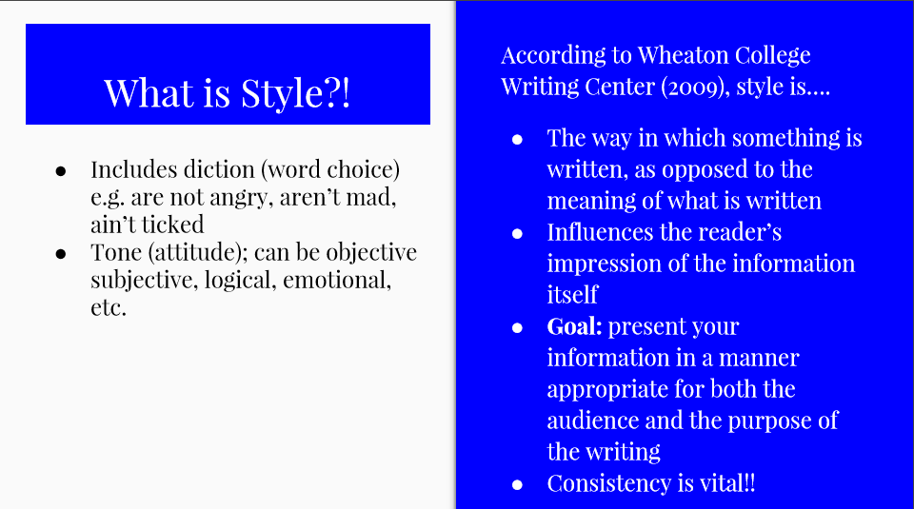
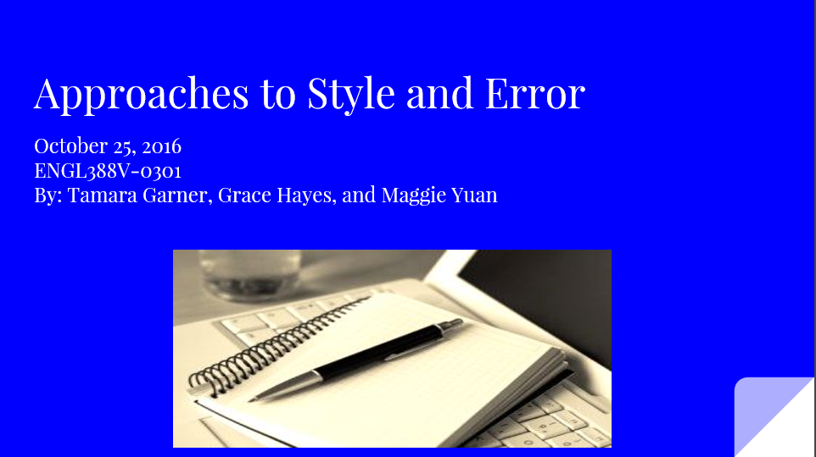
Appendix A:

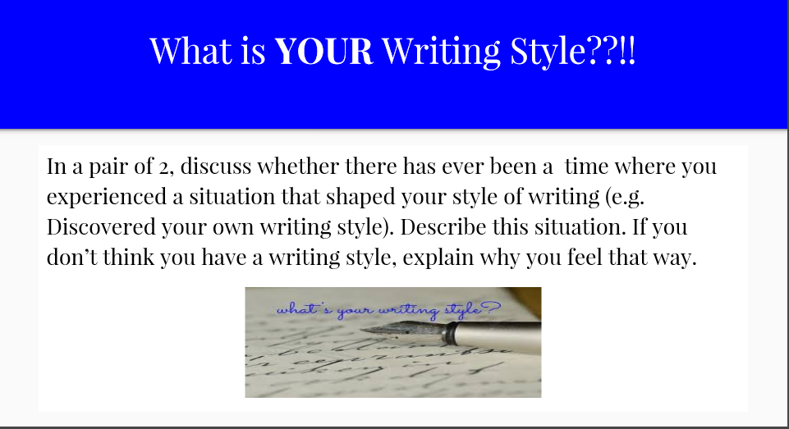
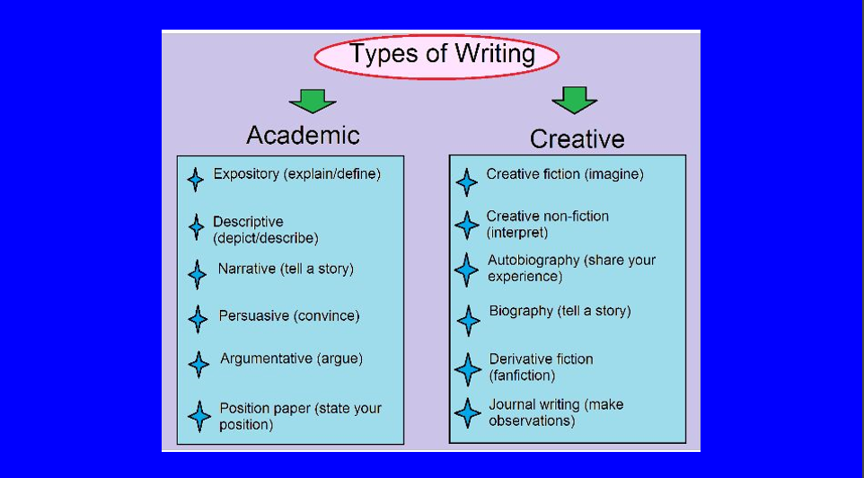

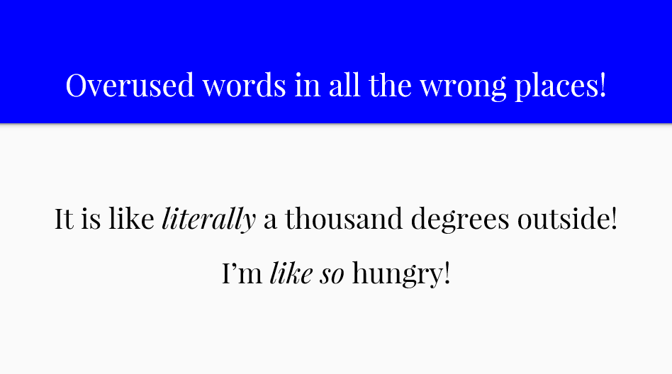

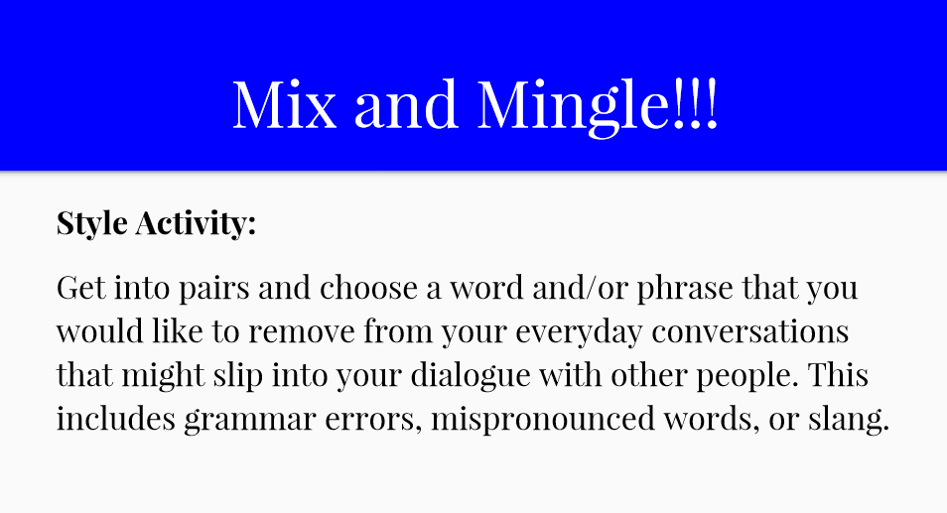

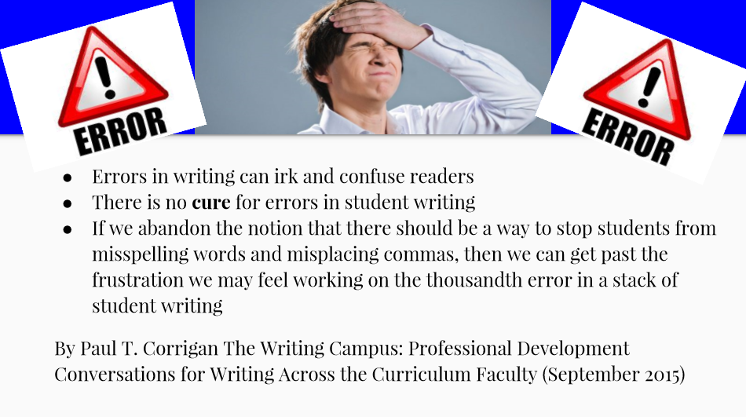

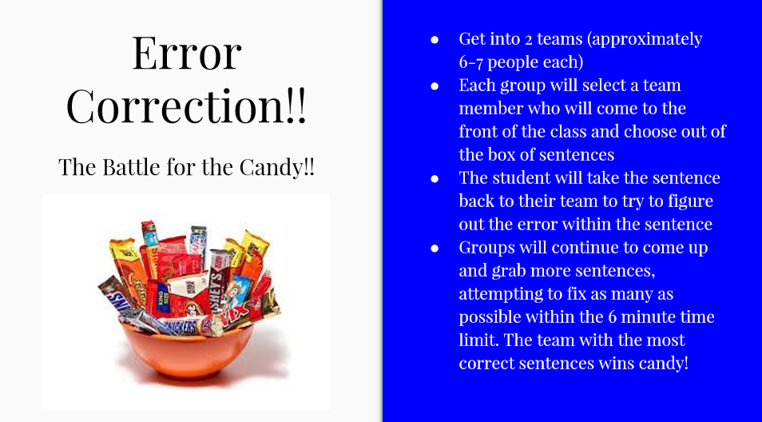

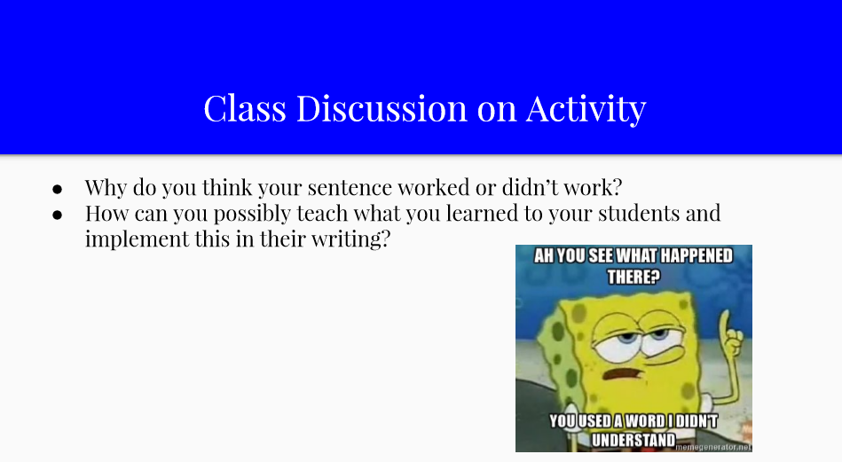

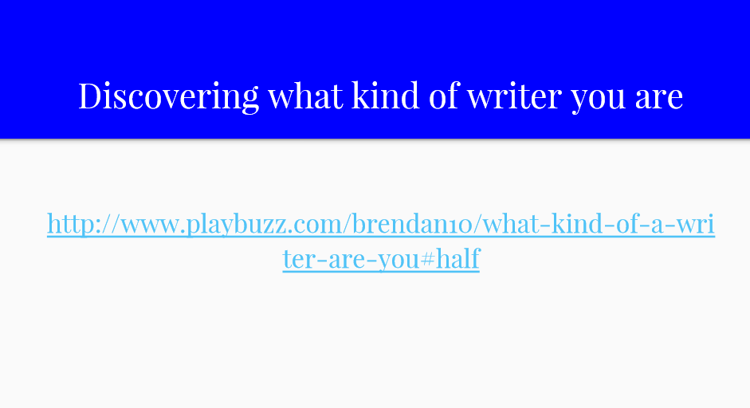

Appendix B:
